Exercise 1: Implementing the Singleton Pattern
Scenario:
You need to ensure that a logging utility class in your application has only one instance throughout the application lifecycle to ensure consistent logging.
Steps:

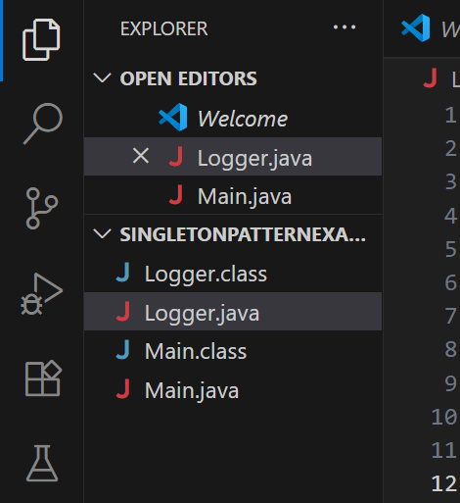

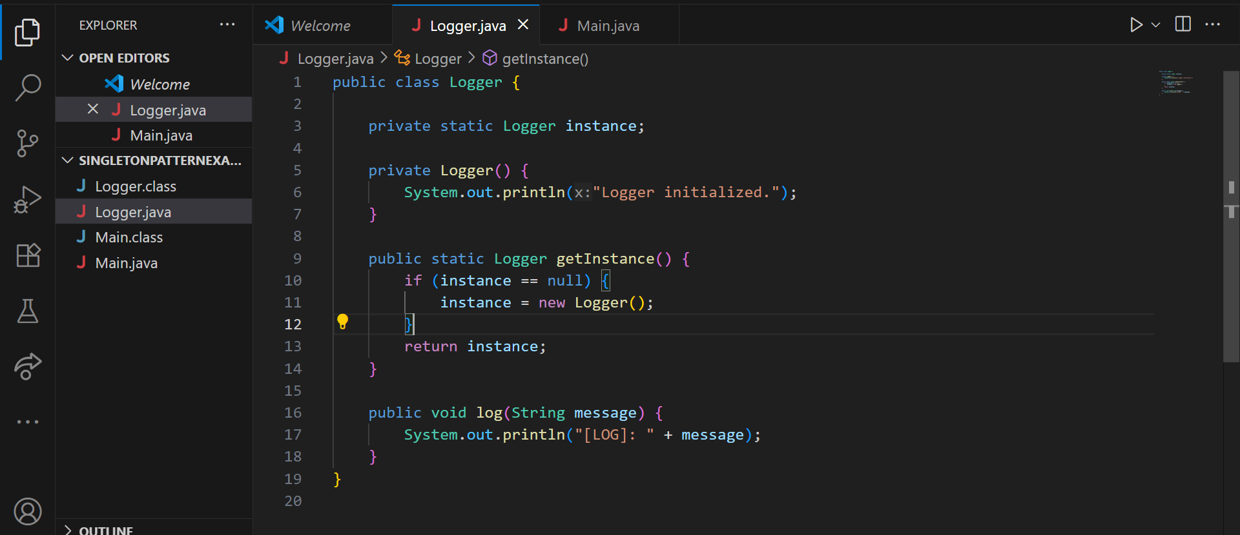

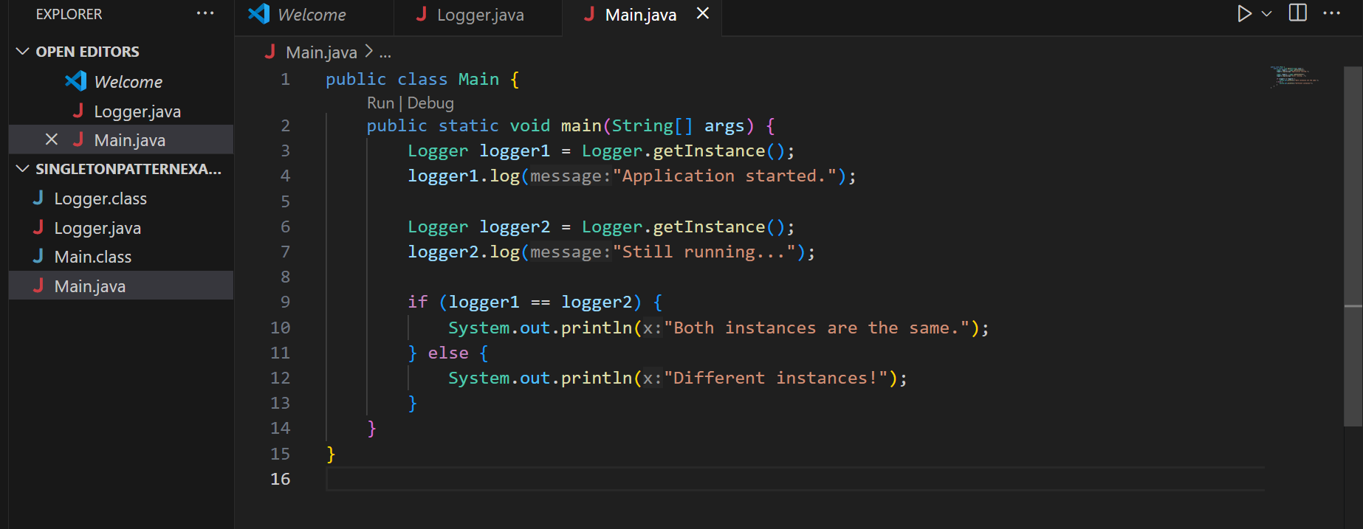

Output:
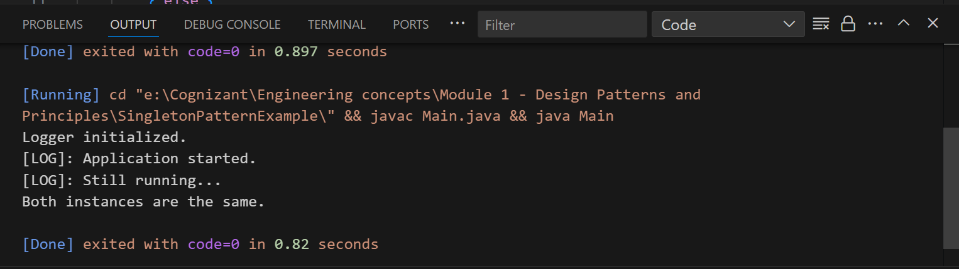

Exercise 2: Implementing the Factory Method Pattern
Scenario:
You are developing a document management system that needs to create different types of documents (e.g., Word, PDF, Excel). Use the Factory Method Pattern to achieve this.
Steps:
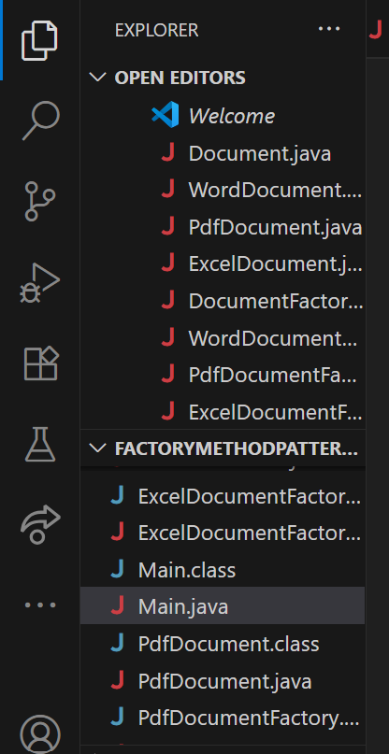

Output:
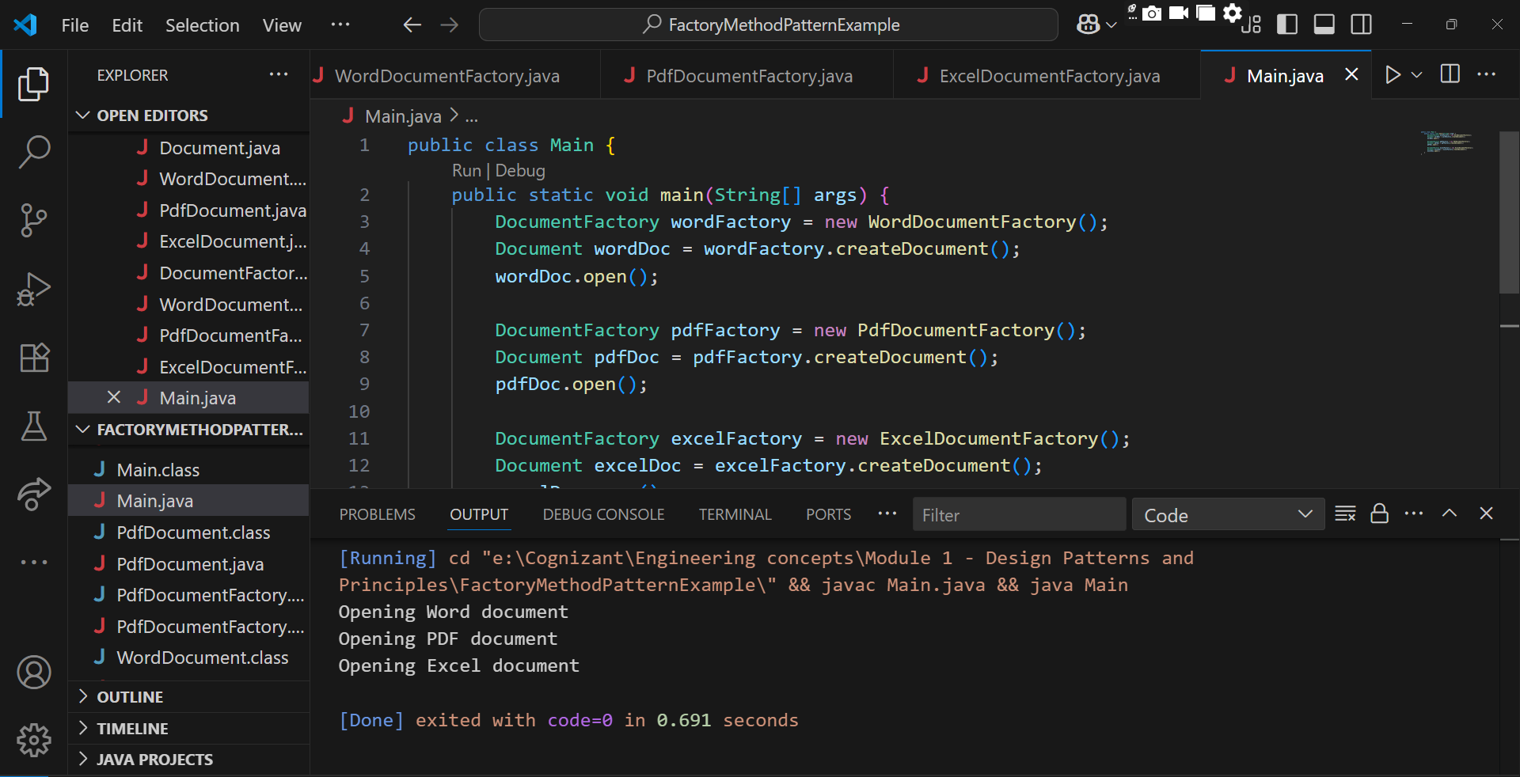

Exercise 3: Implementing the Builder Pattern
Scenario:
You are developing a system to create complex objects such as a Computer with multiple optional parts. Use the Builder Pattern to manage the construction process.

Output:
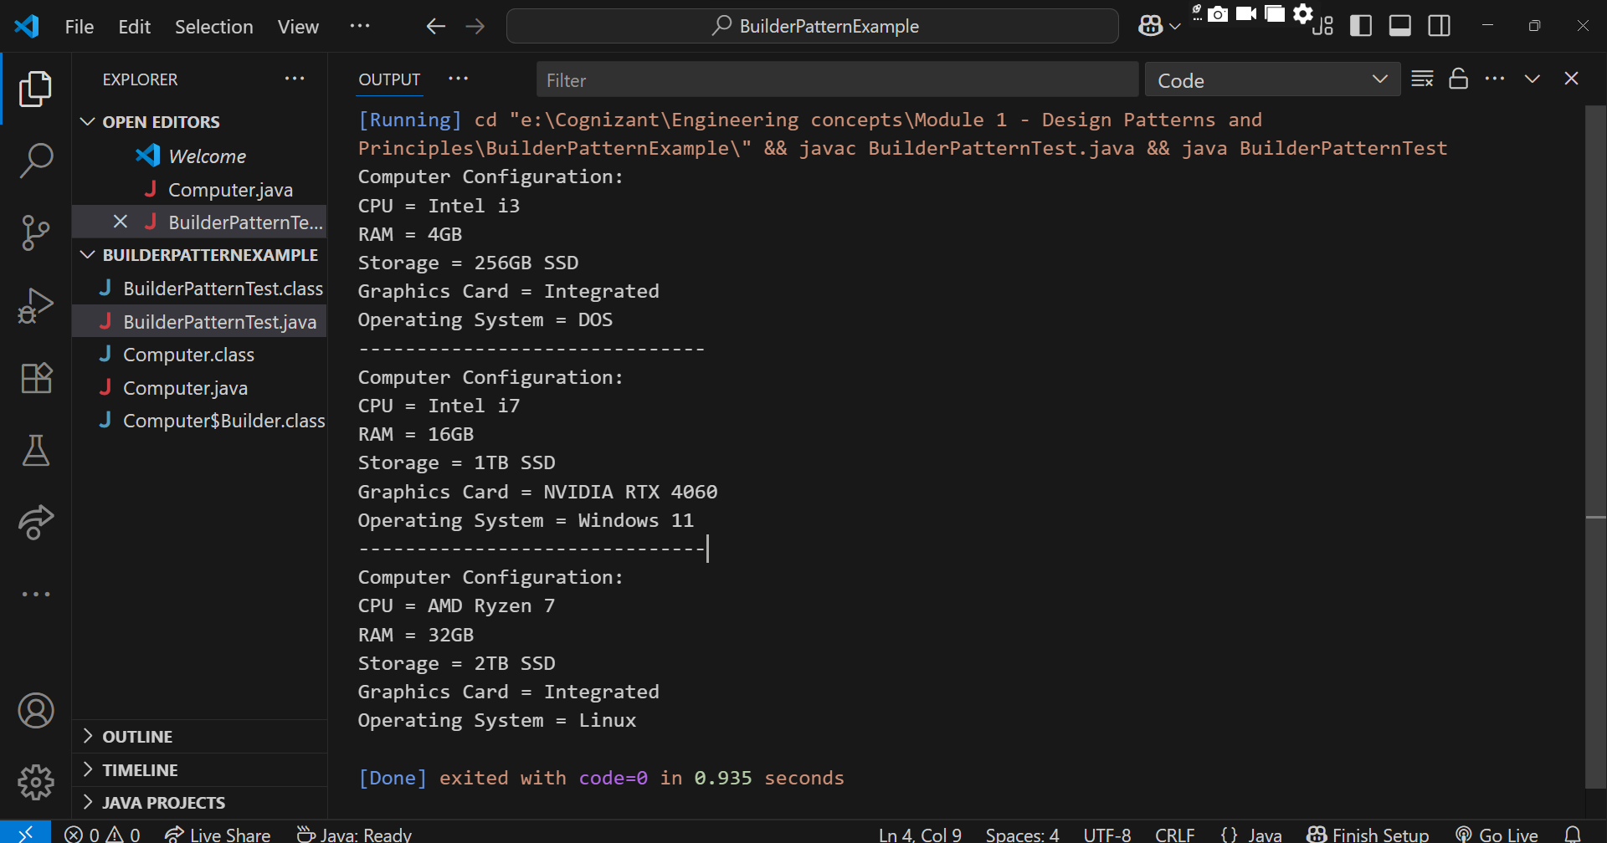

Exercise 4: Implementing the Adapter Pattern
Scenario:
You are developing a payment processing system that needs to integrate with multiple third-party payment gateways with different interfaces. Use the Adapter Pattern to achieve this.

Output:
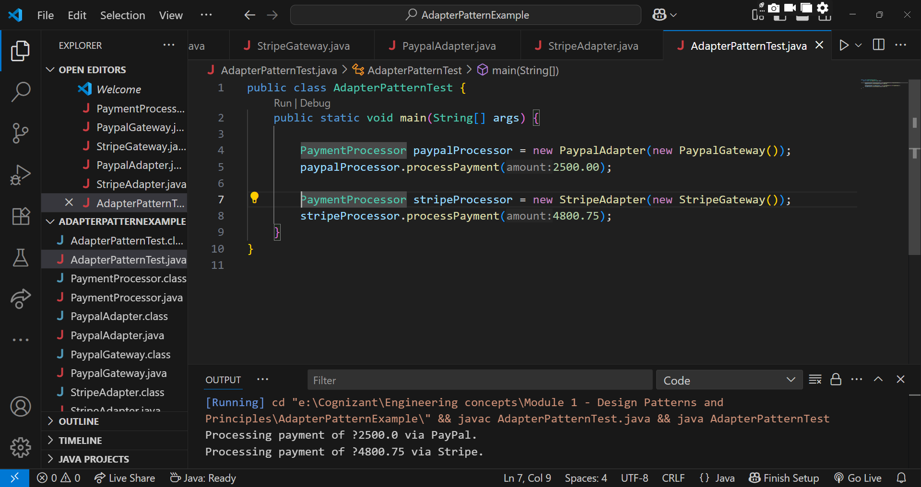

Exercise 5: Implementing the Decorator Pattern
Scenario:
You are developing a notification system where notifications can be sent via multiple channels (e.g., Email, SMS). Use the Decorator Pattern to add functionalities dynamically.
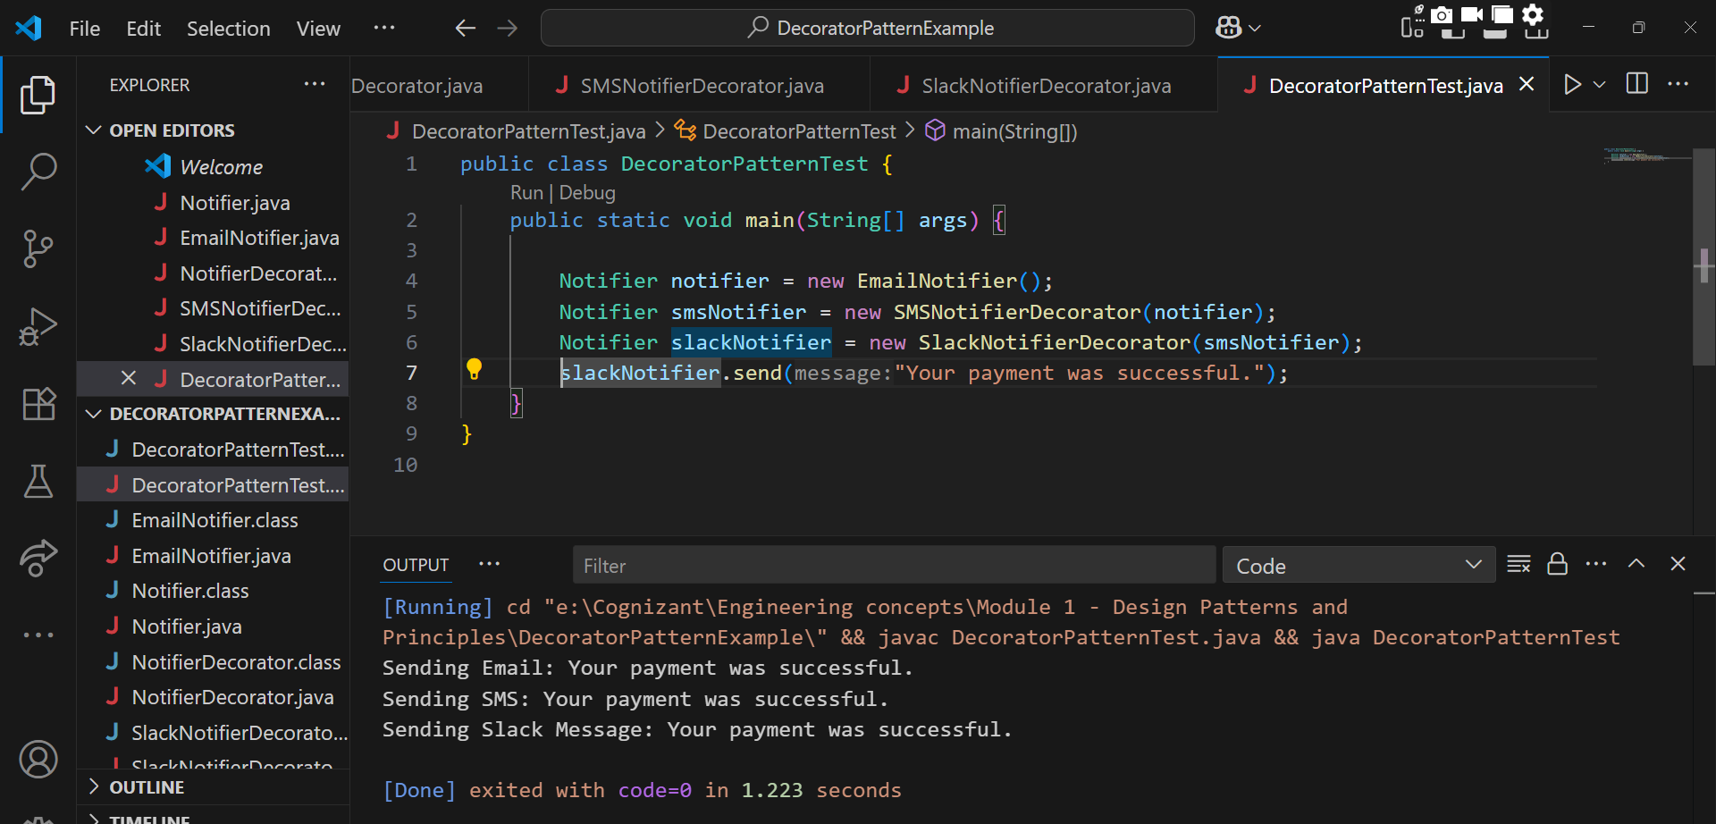

Exercise 6: Implementing the Proxy Pattern
Scenario:
You are developing an image viewer application that loads images from a remote server. Use the Proxy Pattern to add lazy initialization and caching.
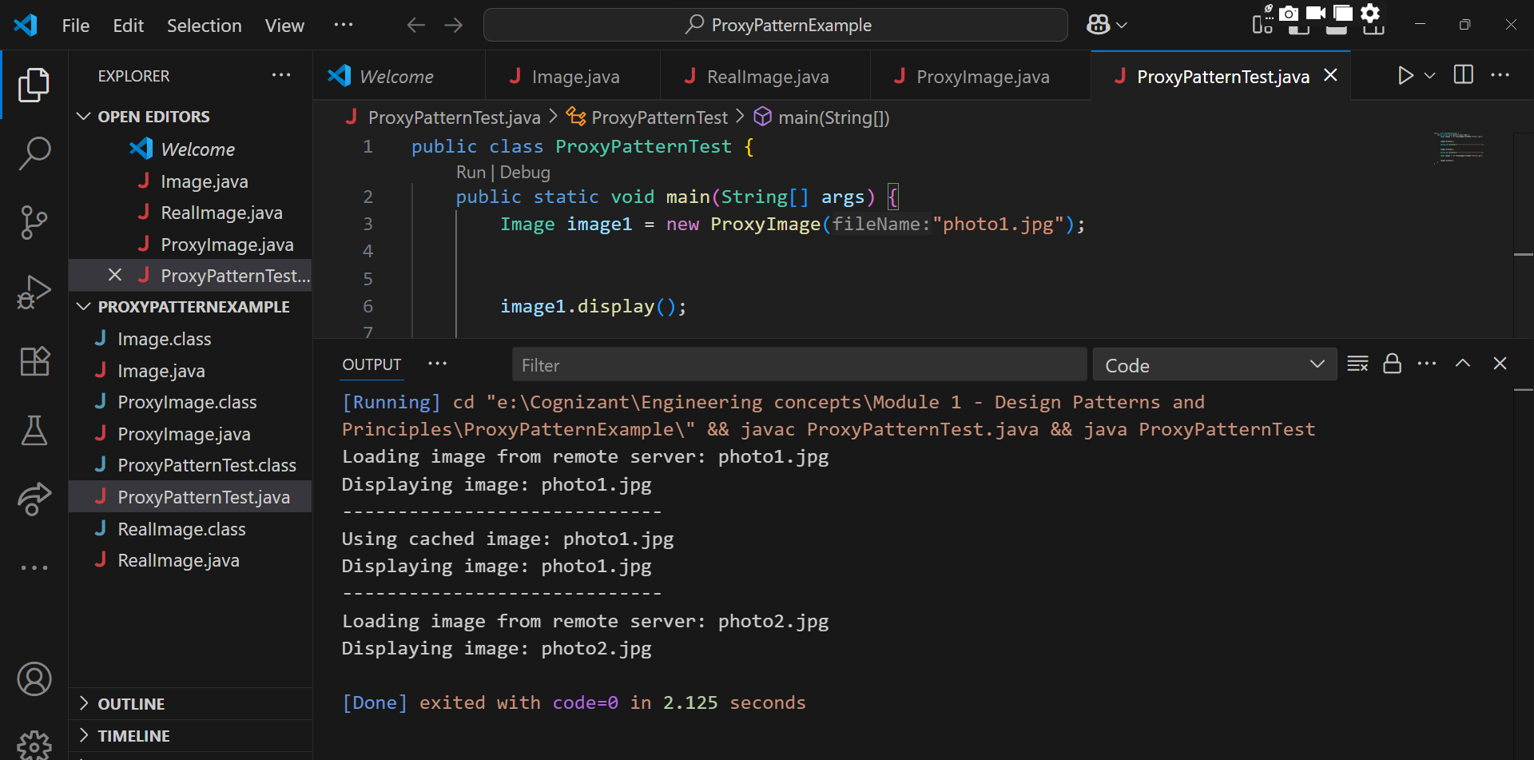

Exercise 7: Implementing the Observer Pattern
Scenario:
You are developing a stock market monitoring application where multiple clients need to be notified whenever stock prices change. Use the Observer Pattern to achieve this.

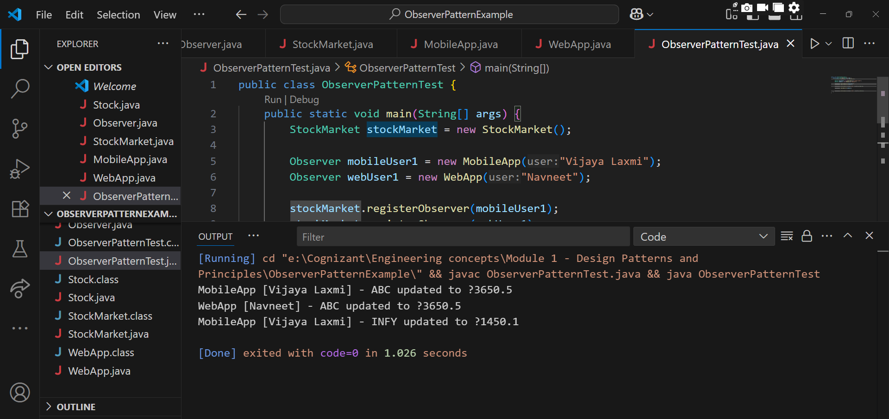

Exercise 8: Implementing the Strategy Pattern
Scenario:
You are developing a payment system where different payment methods (e.g., Credit Card, PayPal) can be selected at runtime. Use the Strategy Pattern to achieve this.
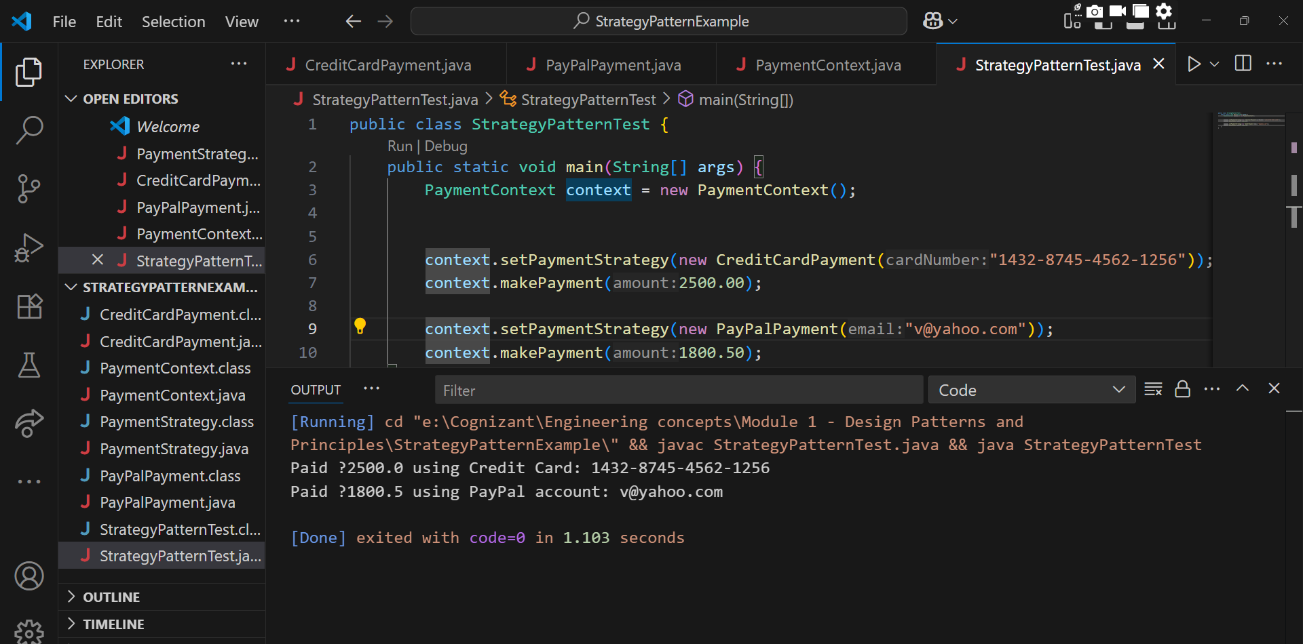

Exercise 9: Implementing the Command Pattern
Scenario: You are developing a home automation system where commands can be issued to turn devices on or off. Use the Command Pattern to achieve this.

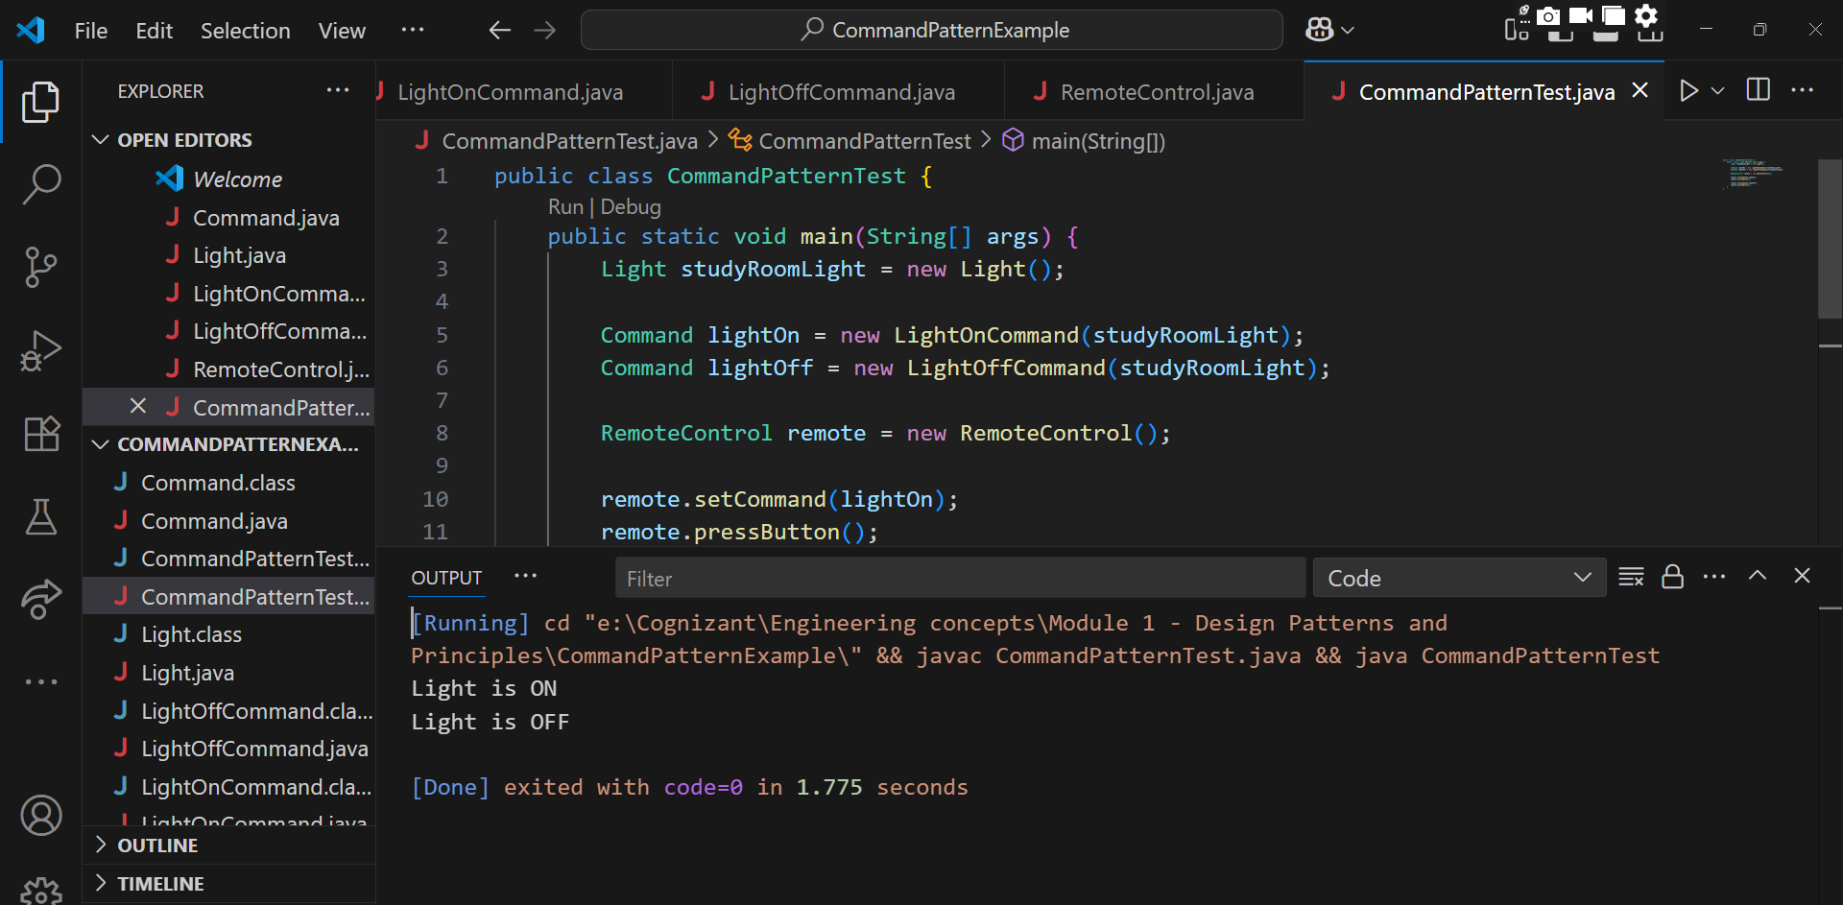

Exercise 10: Implementing the MVC Pattern
Scenario:
You are developing a simple web application for managing student records using the MVC pattern.

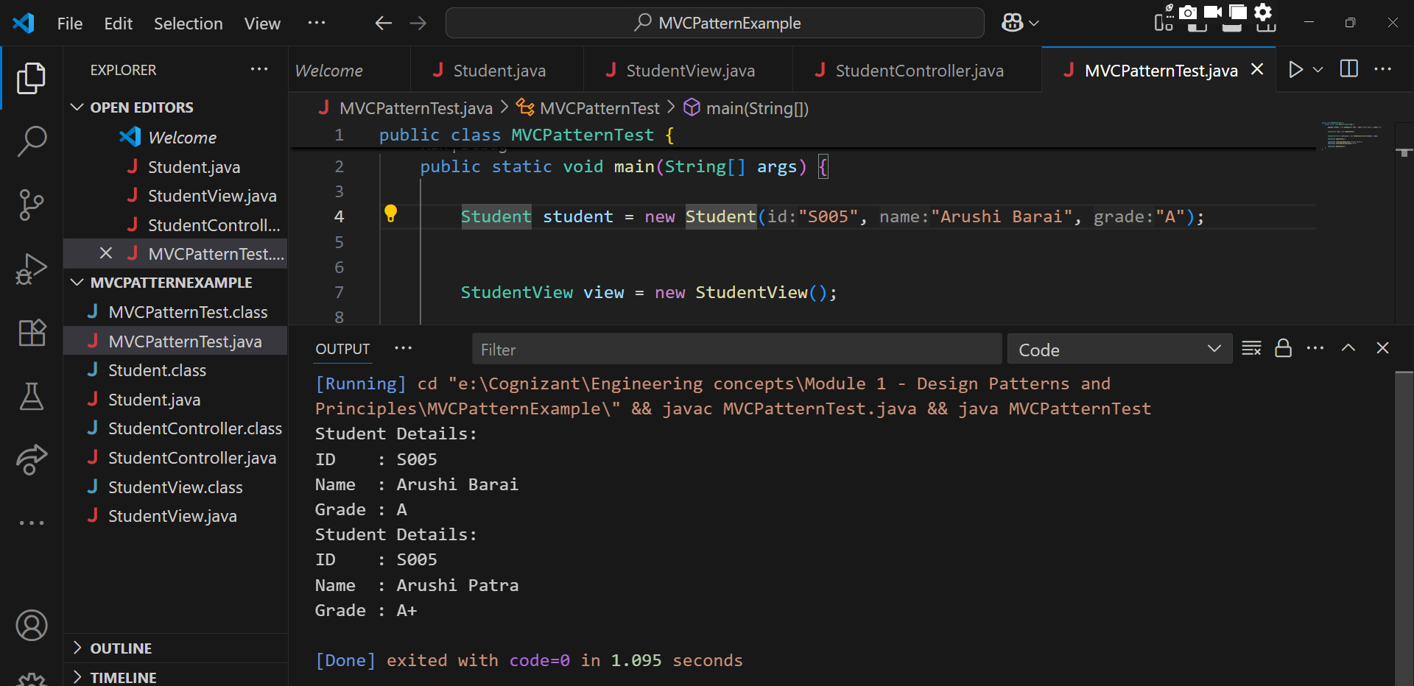

Exercise 11: Implementing Dependency Injection
Scenario:
You are developing a customer management application where the service class depends on a repository class. Use Dependency Injection to manage these dependencies.
